pointer is variable stores address of another variable
15/01/2025
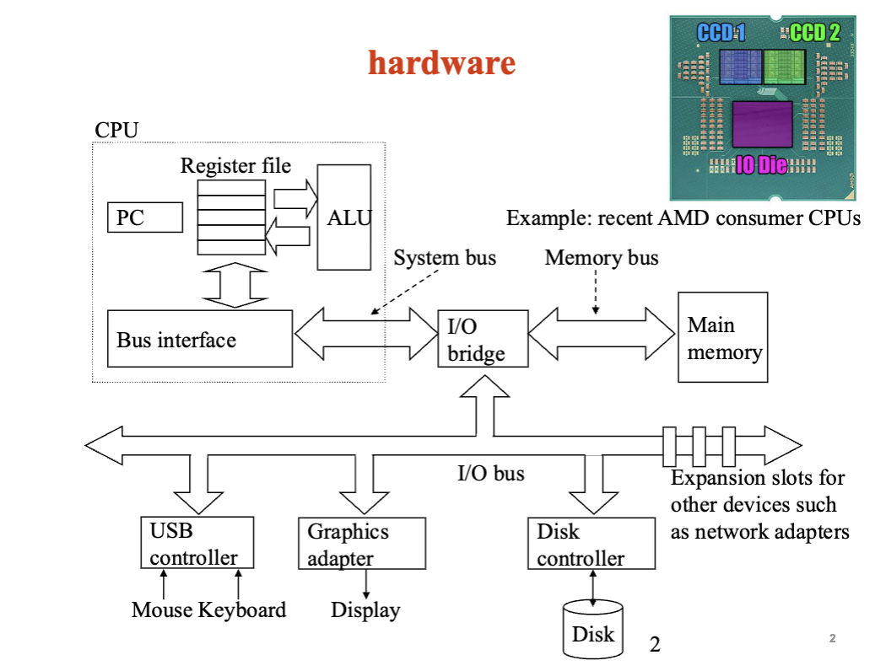
How Hardware Works:
- CPS asks memory answers data Travels on Buses
- Now CPU has memory and understand this words and knows what to do with it
- CPU does the work ( calculates or does the action like adds numbers or checks condition). Work is done and results are created
- Now CPU send the results to memory so it can be used later ( shown on screen, saved, or used by another program)
- If they results need to be shown to you, the computer sends it to output device ( screen, speaker, or printer)
- Computer waits for next command

Hardware:
- CPU: the brain of the computer. It does all the calculations and thinking
  - Register file:
    - very tiny and fast memory inside CPU
    - holds numbers and data the CPU is using right now
  - ALU (Arithmetic Logic Unit):
    - The calculator of the CPU
    - Does the math ( add, subtract) and logic ( compare numbers)

  - Bus interface
    - Connection between the CPU and the rest of the computer
    - Lets data move between CPU and memory or other parts
  - PC (program computer)
    - Tells the CPU which instruction to run the next

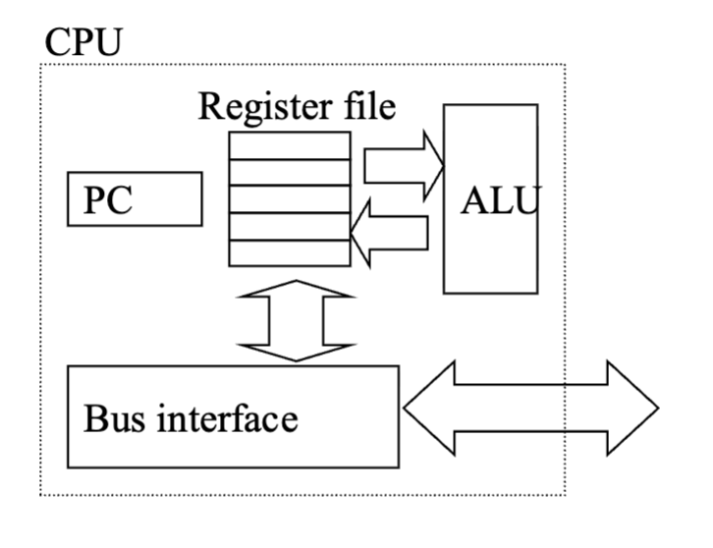
- Buses ( )
  - Buses is a kind of wires transfer data which are called words
  - Moves data with words
    - Words are 4 bytes ( 32 bits)
    - Or 8 bytes ( 64 bites)
  - Word size depends on computer (hardware)
- I/O bridge
  - Middleman between the CPU and input/output devices
  - It helps the cpu talk to slower devices by translating and managing data traffic
- Main memory( RAM)
  - Computer’s short term workspace
  - It temporarily stores programs and data CPU using right now
- I/O bus
  - A pathway that carries data between the CPU, Main Memory and input/output devices ( keyboard, disk, screen)
    - USB controller ( mouse and keyboard) thorugh I/O bus to I/O bridge
    - Graphics Adapter ( display) through I/O bus to I/O bridge
    - Disk Controller ( Disk) through I/O bus to I/O bridge
e.g., Pentium, Sparc, PowerPC, ARM, Zen, Intel Core (These are types of CPU architectures / processor families — basically different kinds of processors made by different companies)

Parallelism: when computer does more than a one thing at the same time. This helps it to finish faster.
- Amdahl’s law: a rule that tells you how much faster a program can run if you make part of it run in parallel.
  - Formula
- Take the fraction of your program that cant be parallelized ( serial part)
- Take the fraction of your program that can be parallelized ( parallel part)
- Divide the parallel part by number of processor you will use
- Add the serial part to the result from step 3
- Divide 1 by total from step 4
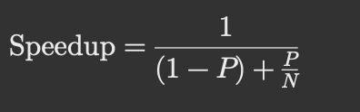
P = fraction that can be done in parallel (0 to 1)
N = number of processors
1-p = part that cant be parallelized
In words: the total speed-up depends on how much can run in parallel and how many processors you have.
Example: If 80% of a program can be parallelized (P = 0.8) and you have 4 processors (N = 4)
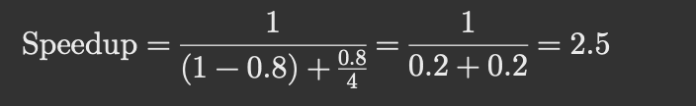
locality: program using same or nearby data repeatedly
- temporal locality: if something is used now it will likely be used again soon Ex: for loop variable
- spatial locality: if you use one item, you will likely use nearby items Ex: Array []
- analogy: library

memory hierarchy

L0: register
L1: on-chip L1 cache (SRAM)
L2: off-chip L2 cache (Sram)
L3: main memory (DRAM)
L4: local secondary storage (local disc)
L5: remote secondary storage (distributive file system, web server)

20/01/26

C programming environment
- A C development environment includes
  - System library and header: Provide built-in functions and definitions.
  - Application source: The C code written by the programmer.
  - Compiler: Converts C code into machine code.
  - Linker: Builds the final executable from compiled code and libraries.

- About C
  - C is not object oriented language
  - C is a middle language between human and assembly language

A simple C probram

/* this is a simple C proram
*some header files*
#includs <stdio.h>
Int main (void)
{
Int NumOfStudents = 24;
Printf (“ Welcome %d students to CIS2107” , NumOfStudents)

Preprocessor diractive …..

Some standard headers

- Stdio.h – file and console ( also a file ) IO: perror, printf, open, close, read, write, scanf, etc.
- Stdlib.h common utility function:
- String.h
- Ctype.h
- Errno.h
- Math.h
- Signal.h
- Stdiant.h
- Time.h
.
- The C preprocessor allows you to define simple macros that are evaluated and expanded prior to compilation
- Commands begin with a ‘#. Abbreviated list:
  - #define:
  - #undef
  - #include
  - #if
  - #idfef
  - #ifndef
  - #else
  - #elif
      - If you write something wrong hard to debug

Variables
- Variables
  - Variable names correspond to locations in the computer’s memory
  - Every variable has a name, a type, a size and value
  - Whenever a new value is placed into a variable ( through scanf , for example), it replaces (and destroyes) the previous value

C variable types
- The most commons are: char, int, float, and double.
- Strings are arrays of characters
- Declare a variable before you use it:
  - Int x;
  - Float y, z = 3.14159
  - Z = 4
  - myVal = 2 it gives error because you need to declare before you give a value

Logical operators
- < ,> ,<= ,>= ,==
- Characters are compared based on their ASCII values

The For loop

- For(int cntr = 0; ctr < 3 ; cntr = cntr + !) {
Printf( “ counter = “, cntr)
}
The while loop
- Cntr = 0;
While(cntr < 3){
Printf(counter, “ counter”)
Cntr ++;}

22/01/26

C: Char **argv java: Sting arg

Floating type
Float
Double
Characters
Char
Boolean
Boolean
Java Primitive Sizes
Type
Byte
Short
Int
Long
Float
Double
Char
boolean
Size(Bytes)
1
2
4
8
4
8
2
1 bit

Why care about size ?
For example, if java’s byte and ling can both represent integers, why use one instead of the other.

C Type Size
Type
Char
Short
Int
Long
Float
Double
Char
Any integer type ( Boolean)

Printing a stuff
#include <stdio.h>

Int main(int argc, char **argv) {
Printf(“welcome to CIS 2107 \n”);

return 0;
}

Int x , y, z;
Printf( “x is %d y is %d z is %d”, x, y, z);
In this line the first %d means a decimal and the order of xyz matters. Here first %d is x, second one is y and third one is z

format specifiers
• %d → integer (int)
• %f → decimal number (float, double)
• %lf → double (mainly for scanf)
• %c → single character (char)
• %s → string (char[])
• %ld → long integer (long)
• %u → unsigned integer
• %x → hexadecimal
• %p → memory address (pointer)

Int x = 10, y = 20

If( x=y){
Printf( “equal \n”);
} else {
Printf(“not equal \n”);
}

Output:
Equal explanation: the x=y condition inside if statement makes x = y
To compare x with y you need to use x == y

01/28/26

Lab 2
Task 2
- Use sizeOf()
Task 3
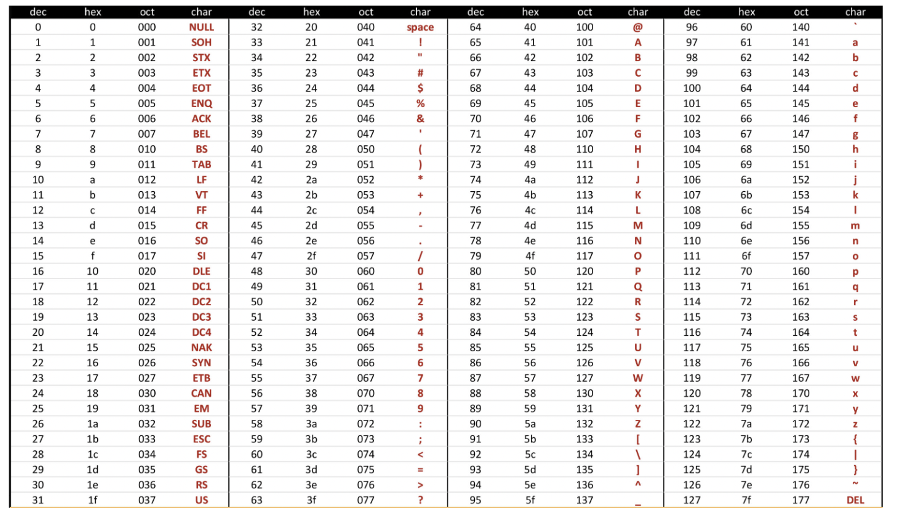

Base
Prefix
Digits
Example
Base | Prefix | Digits | Example | Decimal Value
Decimal | none | 0–9 | 123 | 123
Hex | 0x | 0–9, A–F | 0x1A3F | 6719
Octal | 0 | 0–7 | 075 | 61
Binary | 0b | 0,1 | 0b1011 | 11

01/29/26

Decimals cant be converted to binary perfectly
1.20₁₀ 1.1011010101…₂
Byte = 8 bits
- Binary 0000000₂ to 11111111₂
- Decimal 0₁₀ to 255₁₀
- Hexadecimal 00₁₆ to FF₁₆
  - Base 16 number representation

Xor ( exclusive-Or)
A^B = 1 when either A=1 or B=1, but not both
0 xor 0 = 0
0 xor 1 = 1
1 xor 0 = 1
1 xor 1 = 0

&& and
|| or
~ not
^ xor in C

~0x 00 ~0000 0000 1111 1111 F F
0x 69 & 0x55 69/2 = 33/2 = 16 answer : 01
0x69 | 0x55

Shifting
Lets say argument x = 01100010
- Left shift also means I shift = double the number
  - X << 3 00010000
- Right shift logarithmic
  - X >> 2 00011000
- Right shift arithmetic
  - Most significant one

Numeric range
- Unsigned value
  - uMin = 0
    - 00000….0
  - uMax = 2^{w}-1 w = number of digits.
    - 11111..1
    - Example 4 bit 2⁴ -1 = 15
- Two’s complement value
  - tMin = -2^{w-1}
    - 10000…0
  - Tmax = 2^{w-1}-1
    - 01111…1
- Other values
  - Minus 1
    - 1111…1

02/03/26

signed and unsigned numeric values

signed
- any numeric values including positive and negative
- 2147483647 limit for signed value Max
  - if you add one to it, it goes back to negative limit (-2147483648 is Min number but last number is -1)
unsigned
- only from 0 and positive numbers
- 4294967295U Max limit for unsigned value
  - if you add one to it, it goes back to 0 Min
Casting
- Explicit casting between signed & unsigned same as U2T and T2U ( signed unsigned, unsigned signed)
  - int tx, ty;
  - unsigned ux, uy;
  - tx = (int) ux;
  - uy = (unsigned) ty;
- Implicit casting also occurs via assignments and procedure calls
  - tx = ux;
  - uy = ty;
signed start with 0 goes up to Max and goes back to Min and comes to -1 which is the last or biggest number for signed

unsigned starts with 0 and goes up to Max and goes back to 0 again

sign extension
- task:
  - given w bit signed integer x
  - convert it to w + k but integer with same value
- Rule
  - make k copies of sign bit:
  - x’ = x_{w-1} , …. , x_{w-1} x_{w-1} x_{w-2} , …. , x_{w-0}
| ₋₋₋₋₋₋₋₋₋₋₋₋₋₋₋₋₋₋₋₋₋₋₋₋₋₋₋₋|
K copies of MSB
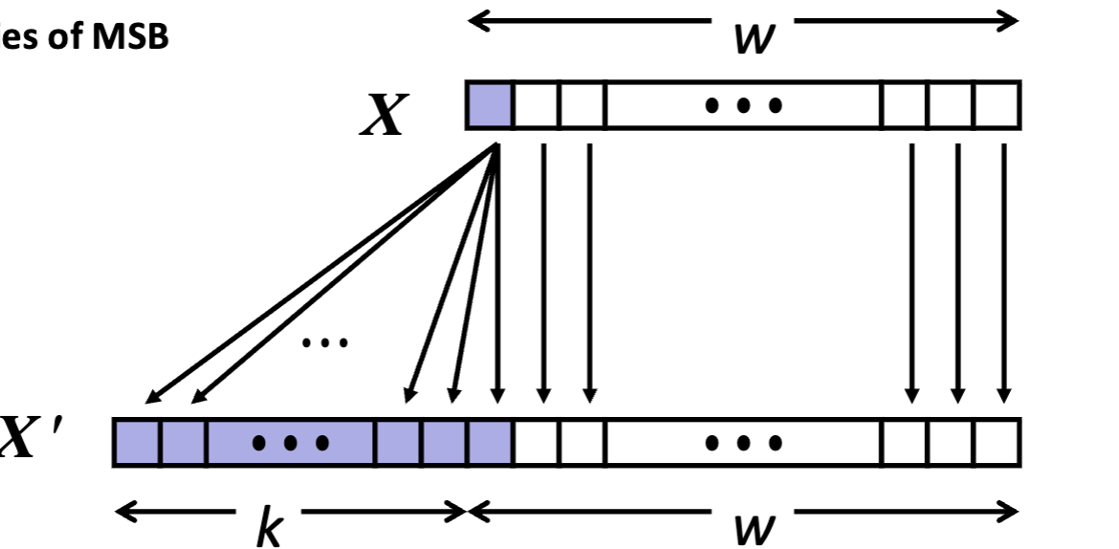

Two’s complement addition
- operands: w bits
- true sum: w+1 bits
- Discard carry: w bits
- 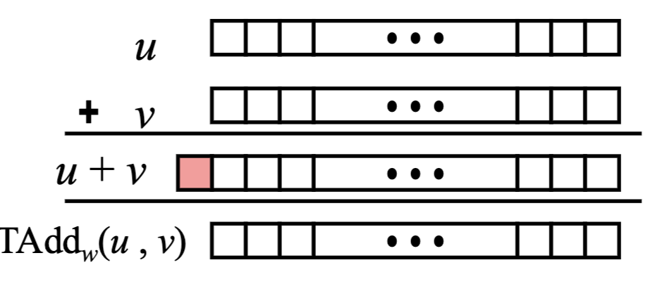
Tadd and Uadd have same identical bit level behavior
- signed vs unsigned addition in C
  - int s, t, u, v
  - s = (int) ((unsigned) u + (unsigned) v );
  - t = u + v;
  - will give s == t
Tadd Overflow
- functionality
  - True sum requires w+1 bits
  - drop off MSB
  - Treat remaining bits as 2’s comp. integer
02/05/2026

Binary fractions and converting

formula:$(\sum{\begin{aligned}i \\ \end{aligned}})$

∑

02/10/2026

Special properties of the IEEE encoding
- FP Zero same as integer Zero
  - all bits = 0
- can (almost) use unsigned integers comparison
  - must first compare sign bits
  - must consider -0 = 0
  - NaNs problematic
    - will be greater than any other values
    - what should comparison yield?
  - otherwise OK
    - Denorm vs normalized
    - normalized vs infinity

Floating point operations: Basic idea
- x +_{f} y = Round (x + y)
- x *_{f} y = Round ( x * y)
- Basic Idea
  - first computer exact result
  - make it fit into desired precision
    - possibly overflow if exponent too large
    - possibly round to fit into frac

Rounding ….
- Rounding Modes (illustrate with $ rounding)

Closer look at Rounding-To-Even…..

Rounding binary numbers ……

adding floating point
in math we say
a+(b+c) = (a+b)+c
but in floating point addition
a+(b+c) ≠ (a+b)+c

(3.14 + 1e10)-1e10 = 0
3.14 + (1e10-1e10) = 3.14
3.14 + inf = inf inf – inf = 0
inf – inf = 0 3.14 + 0 = 3.14

Floating point in C

02/12/2026

Arrays and Functions

c is byte-oriented memory organization
- smallest memory unit is bytes not bit (1 byte – 8 bits)
- array address is like index of array
machine words
- every computer a word size
  - and of address
- 32 bits (4 bytes) as word size
  - limits addresses to 4 gb ( 2³² bytes)
- 64 bit word size
  - could have 18 EB (exabyte) of addressable memory
  - that’s 18.4 x 10¹⁸
- no matter data type (float, fraction, chars)
  - they still sort as number of bytes
Word Oriented Memory Organization
- addresses specify byte locations
  - address of first byte in word
  - addresses of successive words differ by 4(32 bit) or 8 (64 bit)
  - 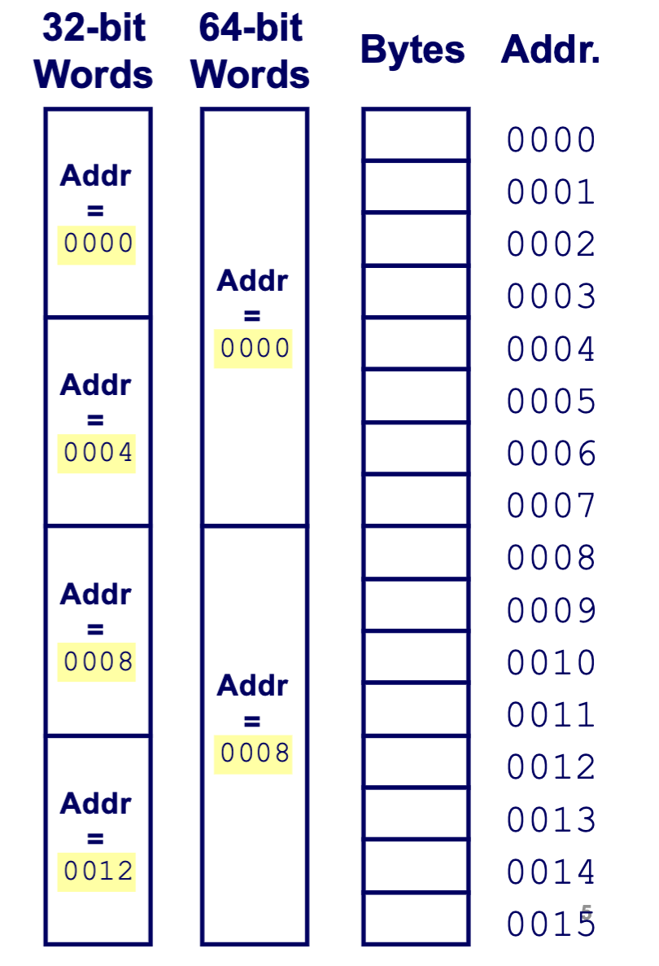
Byte Ordering
- how multi-byte number stored in memory
  - big Endian ( big part first) EX: PPC Mac, Internet (aka network byte order)
    - big/most significant bytes first
    - least significant bytes at the highest address
  - little Endian (little part fist) EX: processors running android, IOS, and windows
    - small/ less significant bytes first
    - largest significant bytes are the highest address
Byte ordering example
- most significant/ big Endian sotres value from left to right
- least significant / little Endian sotres values from right to left

Arrays
- ….

Array Declaration and subscripting
- …..

Arrays in C ( no out of bound exception)
- int array [10]
  - data type array stores
  - name
  - Size
- array[0] first element (index 0)
- array[9] last element (index size – 1)
- array[10], array[-1] out of bound but doesn’t give error

Array size
- int array[10]
  - sizeOf(array[3]);
    - returns size of an object in bytes
  - sizeOf(array); 40 ( usually each int in array is 4 bytes, so 4 * 10)
Multi-Dimensional arrays
- int matrix [2] [3] 2 is rows and 3 is columns
0,0 | 0,1 | 0,2
1,0 | 1,1 | 1,2

printf(matrix[1]) address of [1][0]
matrix[0] address of [0][0]
matrix[0][0] value of [0][0]

Functions
- Function
  - modularizes a program
  - all variables declare inside function are local variables
  - parameters
- benefits of function
  - Divide and conquer
    - manageable program development
  - software reusability
  - avoid code repetition

Syntax
- function definition format
  - return value-type function name (parameter list)
    - return value type: data type of result (default int)
      - Void – return nothing
    - parameter list: comma separated list, declares parameters
  - declaration and statements: function body ( block)
  - if something returns: return expression at the end or when needed

Function calling
- C passes argument to function by value
  - copy of argument passed to function
  - changes in function, do not affect original
void swap(int x, int y)
{ int tmp;
tmp=x;
x=y;
y=tmp;
}
main()
{
int a=10, b=20;
printf(“Before swapping, a=%d,b=%d\n“);
swap(a,b)
printf(“After swapping, a=%d,b=%d\n“);
}
• We need someway to call by reference
so that changes in function effect
original
• pointers ( &a and &b)

02/17/2026

pointers

pointer is variable that takes the location of another variable not the value of the variable

int a = 10;
int b = a;
int *c;

b is pointer
b = location of a
c is a pointer

Pointer Syntax: Type *Name

- Starmark * deference/pointer ( stores the value of the pointed address)
- And Mark & ampersand ( address of …) stores the address of variable
- int x = 5
- int *p = &x
- p = address of x
Address (&) operator
- The address (&) operator can be used in from of any variables in C – the result of the operation is the location in the memory of the variable
- example
  - int v
  - int *p
  - int A[5]
  - &v memory location of variable v
  - &(A[2]) memory location of array element 2 in array A
  - &p memory location of pointer verbale P

Special pointer in C

- always initialize pointer variable to null
- null means pointer pointing to nothing
- if a pointer is Null and you try to access what its pointing to, the program crashes.
- check
  - if(pint != null) { …. }

Swap
- int a
- int b
- swap(&a,&b)
- void swap( int *px, int *py){
- int temp
- temp = *px
- *px = *py
- *py = temp
- }

pointer arithmetic

int pointerX
int a
int b

pointerX = &a
pointerX ++ this changes the pointer to next memory location
so in this case pointerX is not &a but &b ( adds 1 * sizeOf(int) to the memeory address)

same as when variables are char (adds 1*sizeOf(char) to the memeory address)
they need to be used cautiously

Generic pointer
- void *: a “ points to anything”
  - void *p
  - int i
  - char c
  - p = &i
  - p = &c
  - putchar (*(char *) p) type tells the compiler to change an object’s type
  - dangerous but sometimes necessary

Arrays and pointers

